Outputs Of SQL Queries

# Table 1 - USERS

# Table 2 – PRODUCTS

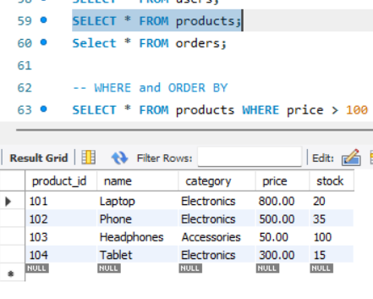

# Table 3- ORDERS

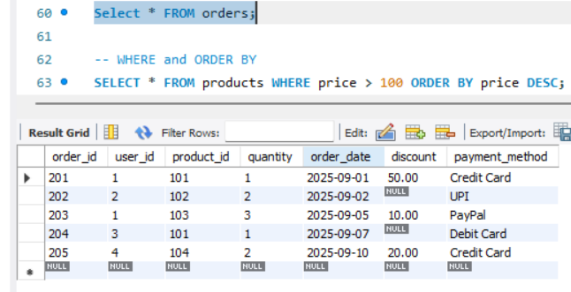

# WHERE and ORDER BY

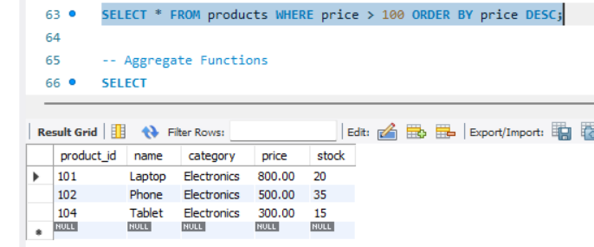

# AGGREGATE FUNCTIONS

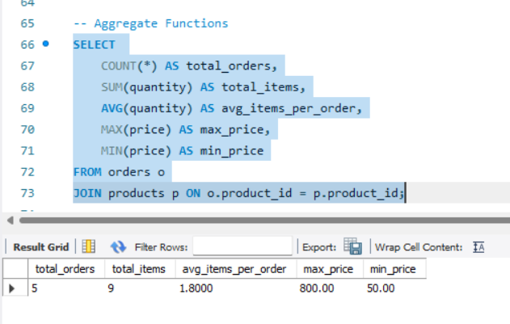

# - JOINS

## INNER JOIN

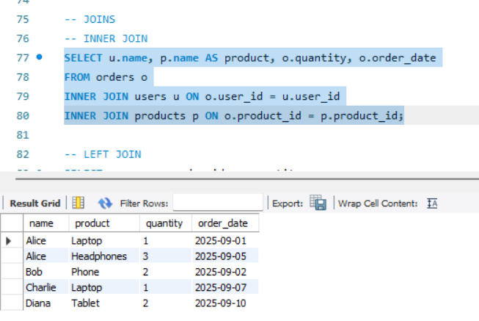

## LEFT JOIN

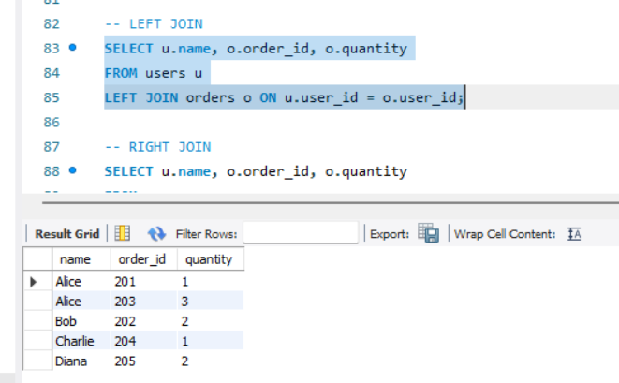

## RIGHT JOIN

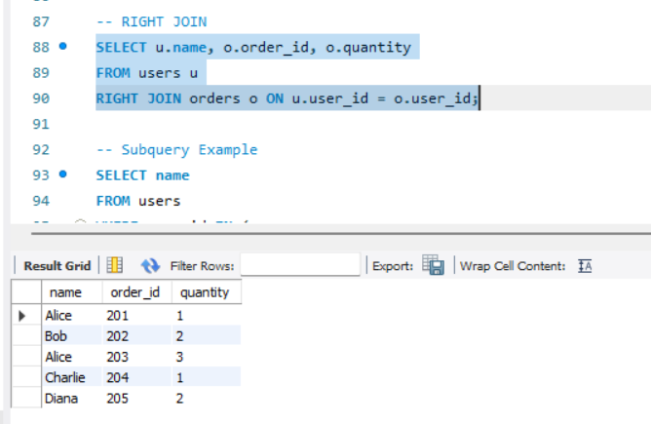

# SUBQUERY

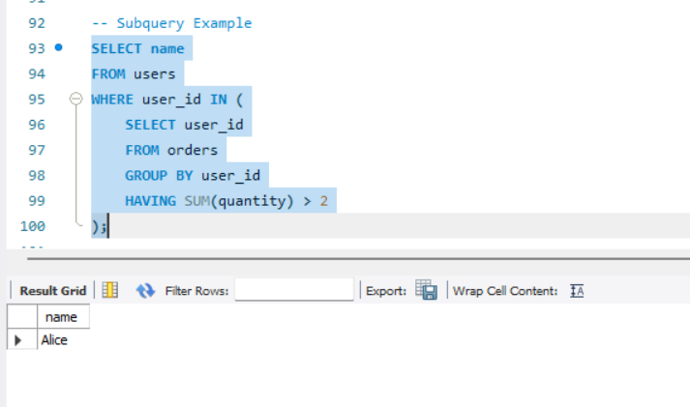

HAVING

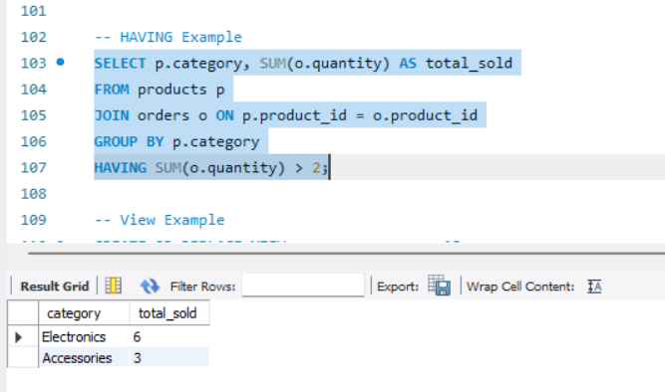

# VIEWS

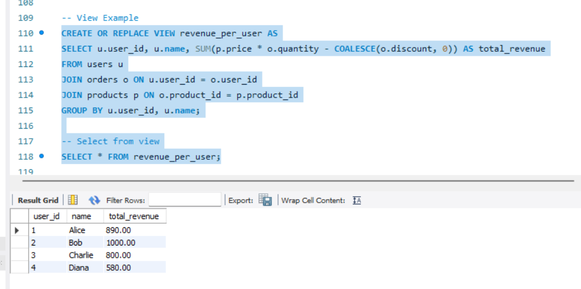

# HANDLING NULL VALUES

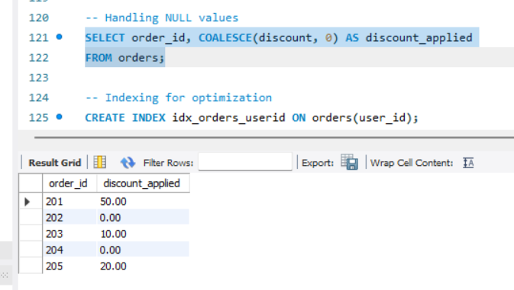

# OPTIMIZE QUERIES WITH INDEXES

